Name: _________Muhammad Uzair______________ Roll No: ____22SW106_________

Score: ____________Signature of the Lab Tutor: _______________ Date: ___________

**________________________________________________________________________**

# OBJECTIVES

|  |  |  |  |  |
| --- | --- | --- | --- | --- |
| **#** | **Topic** | **#. Of**  **Lectures** | **CLO** | **Taxonomy level** |
| 1 | To **operate** the simulation tools for designing complex computer networks using PCs, switches, and router etc. | 3 | 2 | P5 |

# OUTCOME(S)

|  |  |
| --- | --- |
| a. An ability to apply knowledge of math, science, and engineering | PLO1: Engineering Knowledge: |
| k. an ability to use the techniques, skills, and modern engineering tools necessary for engineering practice. | **PLO5:** Modern Tool Usage |

**RUBRICS:**

|  |  |  |  |  |
| --- | --- | --- | --- | --- |
| **Performance**  **Metric** | **Exceeds expectation (4-5)** | **Meets expectations**  **(2-3)** | **Does not meet**  **expectations (0-1)** | **Score** |
| Knowledge and  application  [PLO1] | Applies the appropriate knowledge and concepts to the problem with accuracy and proficiency; shows precise understanding of these knowledge and concepts. | Applies the relevant knowledge and concept to the problem, possibly in a roundabout way; understands the major points of the knowledge, with possible  misunderstanding or failure to recall minor points; | Fails to apply relevant knowledge and concepts to the  problem; misunderstands or fails to recall critical points. |  |
| Modern Tool  Usage [PLO5] | Computer and software are extensively used in the course | Computer and software are somewhat utilized, effort was put into learning new software | Computer and software are not utilized, no attempt was made at learning new software |  |
|  |  |  | **Total Score** |  |

# *EQUIPMENT*

* PC with operating system
* Packet Tracer 5.3

DISCUSSION:

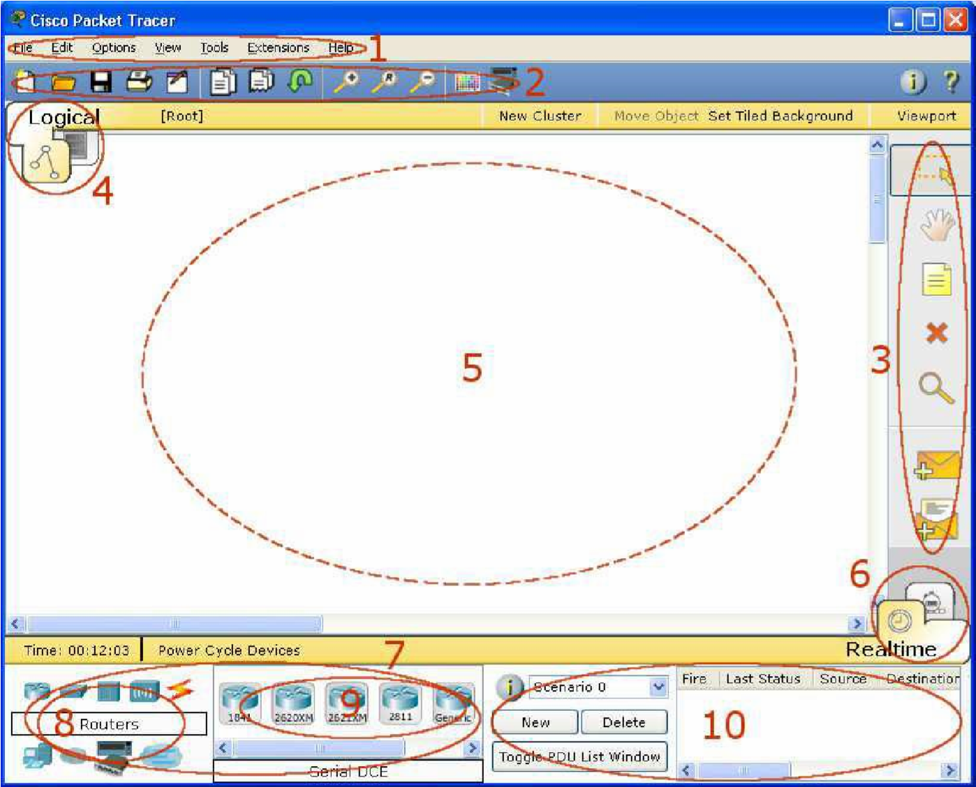

|  |  |  |
| --- | --- | --- |
| 1 | **Menu Bar** | This bar provides the **File**, **Edit**, **Options**, **View**, **Tools**, **Extensions**, and **Help** menus. You will find basic commands such as **Open**, **Save**, **Print**, and **Preferences** in these menus. You will also be able to access the **Activity Wizard** from the **Extensions** menu. |
| 2 | Main Tool Bar | This bar provides shortcut icons to the File and Edit menu commands. This bar also provides buttons for Zoom, the drawing Palette, and the Device Template Manager. On the |

|  |  |  |
| --- | --- | --- |
|  |  | right, you will also find the Network Information button, |
|  |  | which you can use to enter a description for the current network (or any text you wish to include). |
| 3 | Common Tools  Bar | This bar provides access to these commonly used workspace tools:  Select, Move Layout, Place Note, Delete, Inspect, Add  Simple  PDU, and Add Complex PDU. See "Workspace Basics" for more information. |
| 4 | Logical/Physical  Workspace and  Navigation Bar | You can toggle between the Physical Workspace and the  Logical Workspace with the tabs on this bar. In Logical Workspace, this bar also allows you to navigate through levels of a cluster, create a New Cluster, Move Object, Set Tiled Background, and Viewport. In Physical Workspace, this bar allows you to navigate through physical locations, create a New City, create a New Building, create a New Closet, Move Object, apply Grid to the background, Set Background, and go to the Working Closet. |
| 5 | Workspace | This area is where you will create your network, watch simulations, and view many kinds of information and statistics. |
| 6 | Realtime/Simulation  Bar | You can toggle between Realtime Mode and Simulation Mode with the tabs on this bar. This bar also provides buttons to Power Cycle Devices as well as the Play Control buttons and the Event List toggle button in Simulation Mode. Also, it contains a clock that displays the relative Time in Realtime Mode and Simulation Mode. |
| 7 | Network  Component Box | This box is where you choose devices and connections to put into the workspace. It contains the Device-Type  Selection Box and the Device-Specific Selection Box. |
| 8 | Device-Type  Selection Box | This box contains the type of devices and connections available in Packet Tracer 5.1. The Device-Specific Selection Box will change depending on which type of device you choose. |
| 9 | Device-Specific  Selection Box | This box is where you choose specifically which devices you want to put in your network and which connections to make. |
| 10 | User Created Packet | This window manages the packets you put in the network |

during

|  |  |  |
| --- | --- | --- |
|  | Window | simulation scenarios. See the "Simulation Mode" section for more details. |

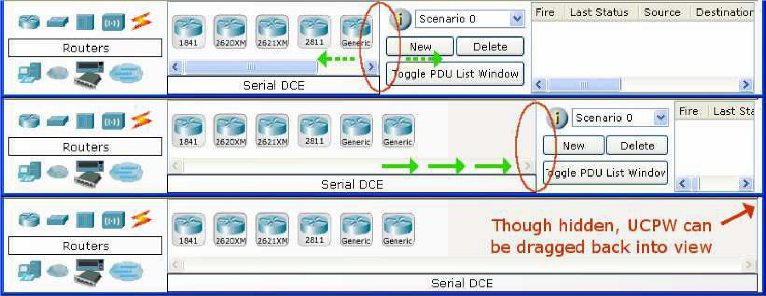

## 2. Creating Devices

1. Choose a device type from the **Device- Type Selection** box
2. Click on the desired device model from the **Device-Specific Selection** box
3. Click on a location in the workspace to put your device in that location
4. If you want to cancel your selection, press the **Cancel** icon for that device
5. Alternatively, you can click and drag a device from the **Device-Specific Selection** box onto the workspace
6. You can also click and drag a device directly from the **Device-Type Selection** box and a default device model will be chosen for.

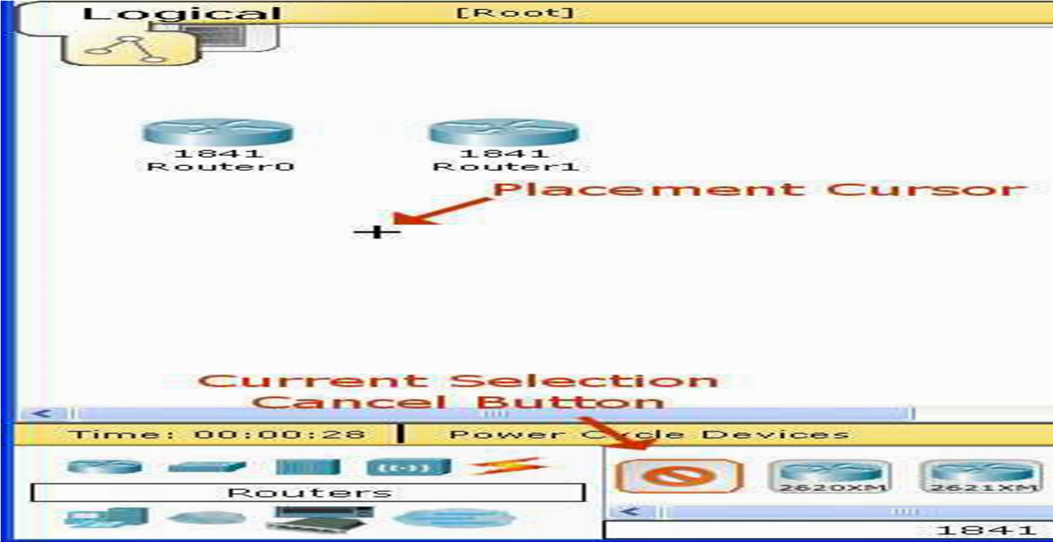

**3**

**.**

**Adding Mod**

**ules**

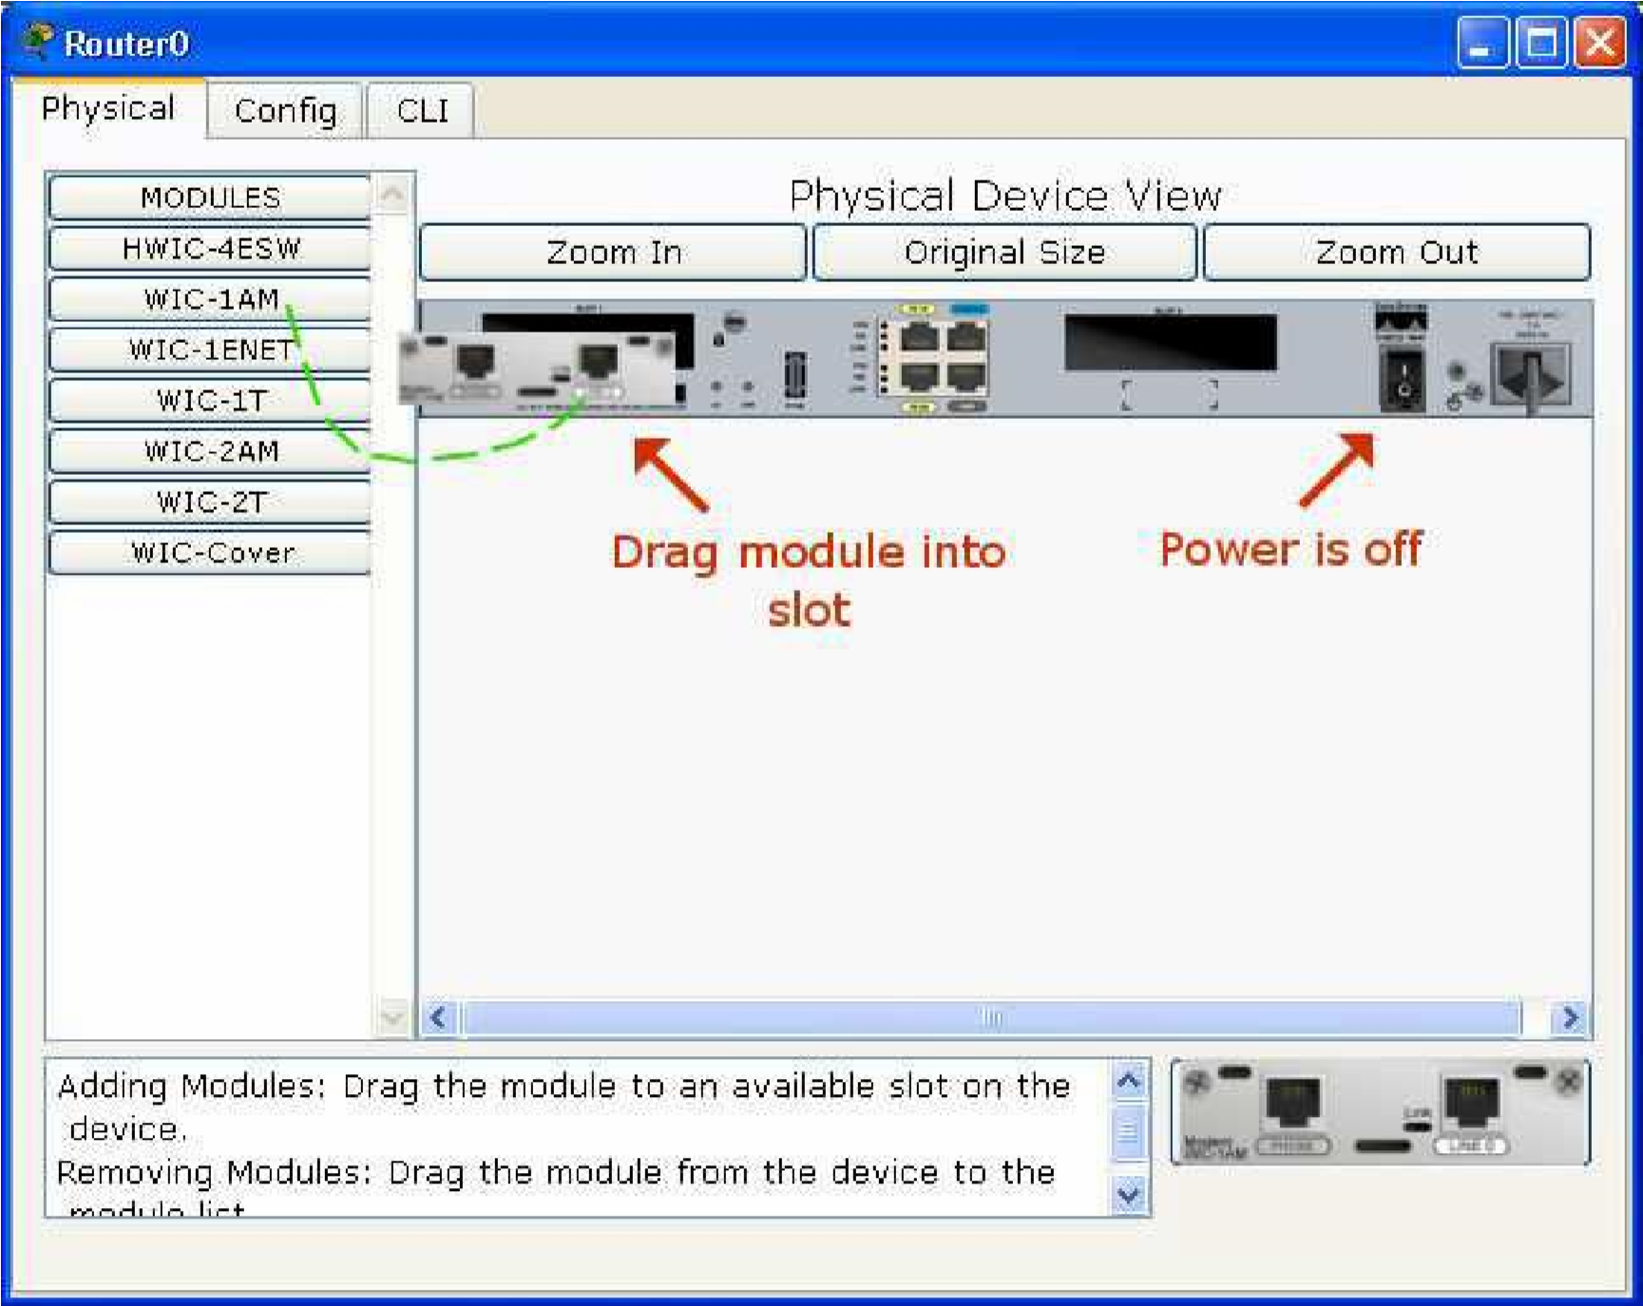

1. Click on a device to bring up its configuration window.
2. By default, you will be in the **Physical Device View** subpanel of the device.
3. You can browse (by clicking) through the list of modules and read their description in the information box at the bottom.
4. When you have found the module you want to add, simply drag it from the list into a compatible bay on the device picture.
5. You can remove a module by dragging it from the device back into the list.

## 4. Making Connections

a. To make a connection between two devices, first click the **Connections** icon from the **Device-Type Selection** box to bring up the list of available connections. b. Then click the appropriate cable type.

1. The mouse pointer will change into a "connection" cursor.
2. Click on the first device and choose an appropriate interface to which to connect.
3. Then click on the second device and do the same.

1. A connection cable will appear between the two devices, along with link lights showing the link status on each end (for interfaces that have link lights).

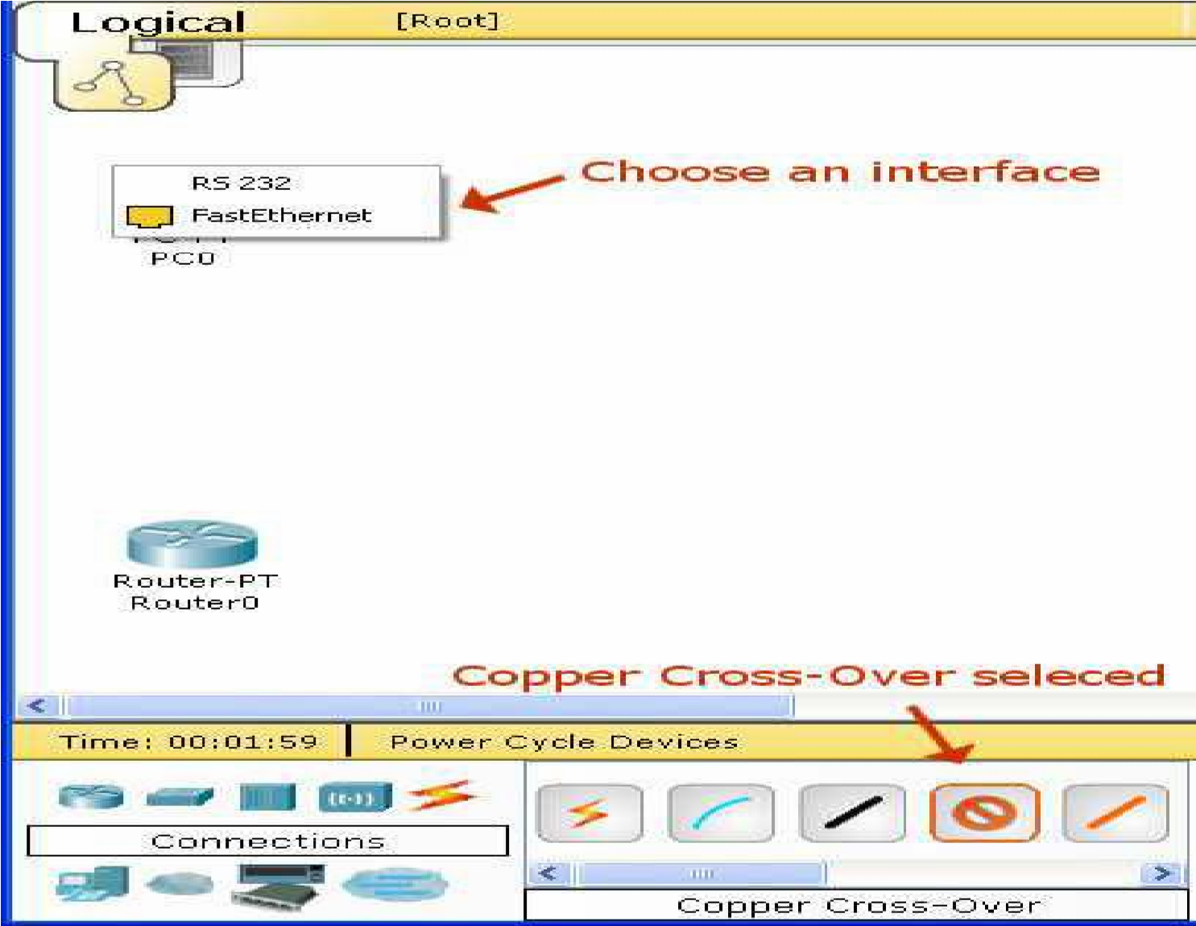

**5**

**. Creating Networks**

a.Start creating a network by first selecting the End Devices. Add a Generic PC and a Generic Server to the workspace.

b.Under Connections, select the Copper Straight-through cable (solid black line) and connect the

devices with it. The red lights on the link indicate that the connection is not working. Now, use the Delete tool to remove the Copper Straight-through cable, and use a Copper Cross-over cable (dashed line) instead. The lights should turn green at this point, and if the mouse pointer is held over either the PC or the Server, the link status will be shown as “Up.” The network should look similar to the picture above.

c.Click on the PC. While paying attention to the link lights, turn the power on, off, and on again. Follow the same steps for the server. The link lights turn red when the device is off. This means that the link is down or is not working. The link lights turn green when the device is turned back on.

d.Try all three ways to learn about the devices. First, mouse over the devices to see basic configuration information about them. Second, click on each device with the Select tool to show the device configuration window, which provides several ways to configure the device. Third, use the Inspect tool to view tables the network device will build as it learns about the network around it. In this example, only the ARP tables will appear. Since the devices have not been configured yet, the ARP tables are empty. Always remember to

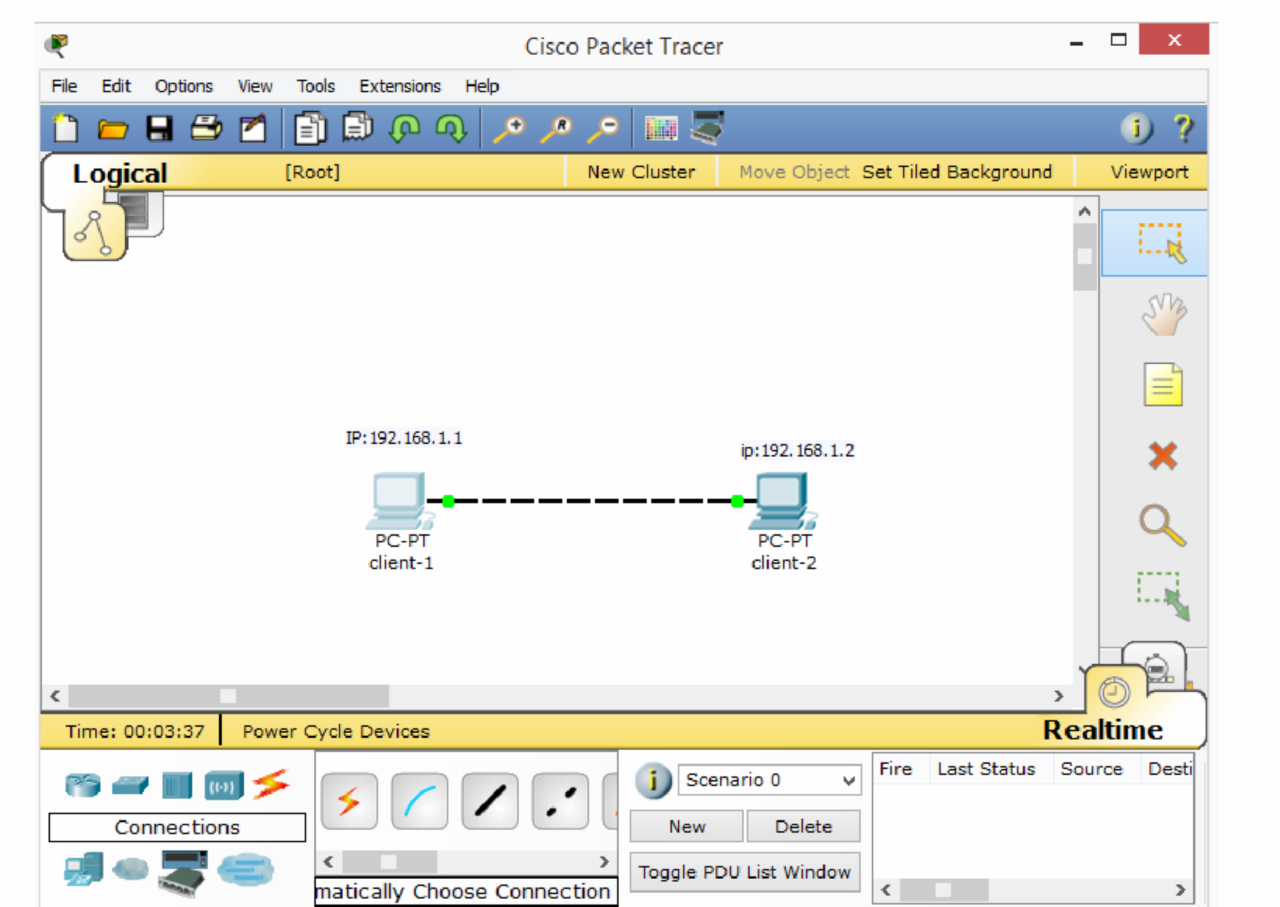

close windows after viewing them or they will clutter the workspace.

e.Open the PC configuration window and change the settings using the Config tab. Change the display name to Client-1. Under Interface, click FastEthernet and set the IP address as **192.168.1.1**. Packet Tracer automatically calculates other parameters. Make sure that the Port Status box is checked. For future reference, note that other Ethernet interface settings, such as bandwidth, duplex, MAC address, and subnet mask can be modified using this window.

f. Go to the Desktop Tab and click on IP Configuration. Notice that the IP address, subnet mask can be changed here as well.

g.Open the other PC configuration window and go to the Config tab. Change the display name to client-2. Click FastEthernet and set the IP address as **192.168.1.2**.

Make sure that the Port Status is also on.

h.Reposition the network devices by dragging them to a new location. Add a network description by using the “i” button on the upper right corner. Then add some text labels within the Logical Workspace by using the Place Note tool.

1. Load a background grid using the Set Tiled Background button.

Save your work using the File > Save As option and create a meaningful filename.

Question 1: If I want to change the module, what are necessary steps to be done first? Explain.

**Answer:**  
To change a module in a device, first, click on the device in the workspace to open its configuration window. By default, you will see the Physical Device View. Browse through the list of available modules and select the module you want. Simply drag this module from the list to a compatible slot on the device. If you need to remove a module, drag it from the device back to the list. Ensure that the device is powered off if necessary to prevent configuration issues before adding or removing modules.

Question 2: How does a switch build its MAC table? Justify your answer with an example.

**Answer:**  
A switch builds its MAC table by learning the MAC addresses of connected devices as they send data. When a frame arrives at a switch port, the switch records the source MAC address and associates it with that port in its MAC table. For example, if a PC with MAC address 00:1A:2B:3C:4D:5E sends a frame to another device, the switch learns that this MAC address is connected to the specific port on which the frame was received. If another device sends a frame to 00:1A:2B:3C:4D:5E, the switch checks its MAC table and forwards the frame only to the corresponding port, optimizing network traffic.

**Question 3: How to check connectivity among end devices in real-time mode and simulation mode in Cisco Packet Tracer?**

**Answer:**  
To check connectivity in **Realtime Mode**, simply configure the devices with IP addresses and then use the "ping" command from one device to another. If the connection is working, you will receive a reply showing that the devices are reachable.

In **Simulation Mode**, after configuring the IP addresses, initiate a ping. In this mode, the Packet Tracer will display each step of the packet’s journey between devices, showing the progress of each packet through the network. You can use the Play Control buttons to observe the packet’s travel and analyze any connectivity issues or delays in packet delivery.

**TASK-1:-**

Submit a lab with performing a simple task by designing a star topology with three PC’s

connected to hub. Show number of collisions of this topology using simulation mode of packet

tracer with screen shots.

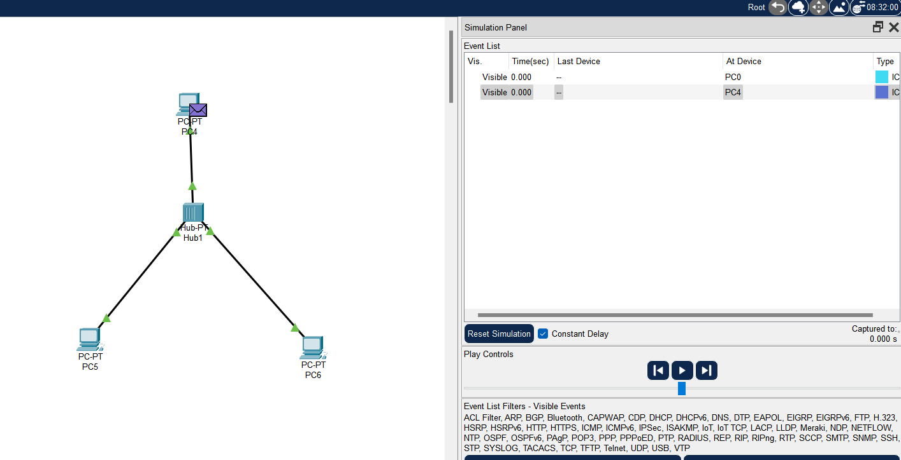

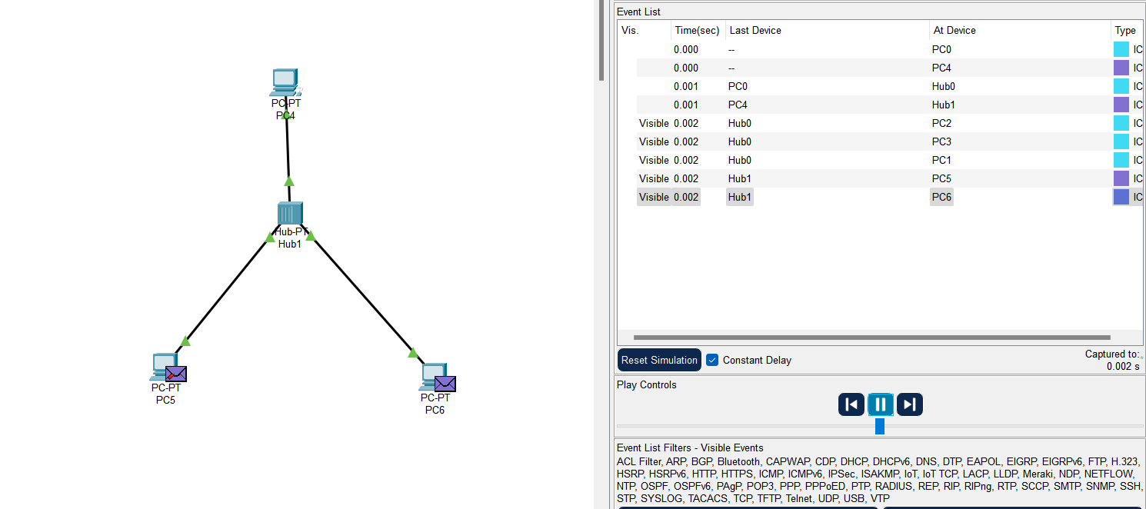

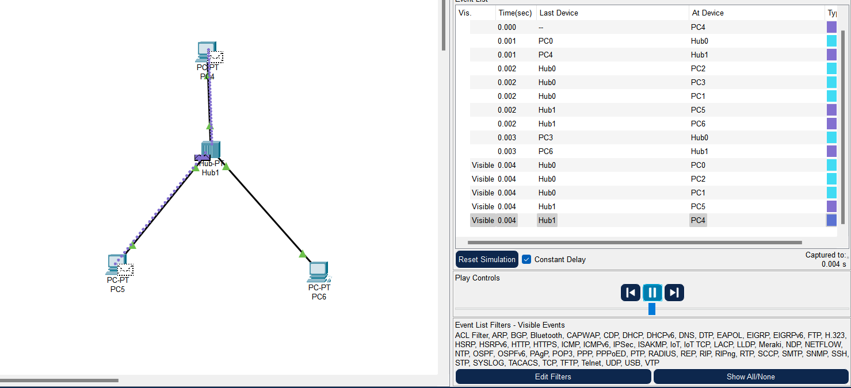

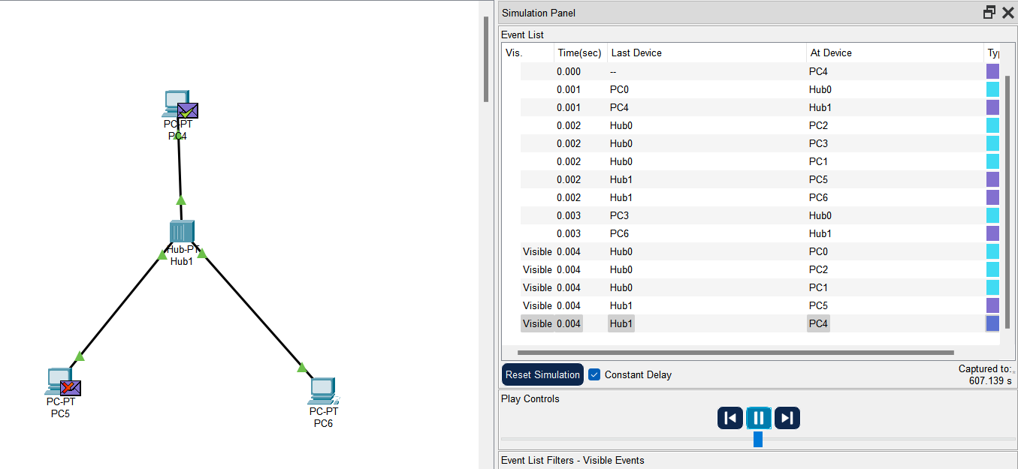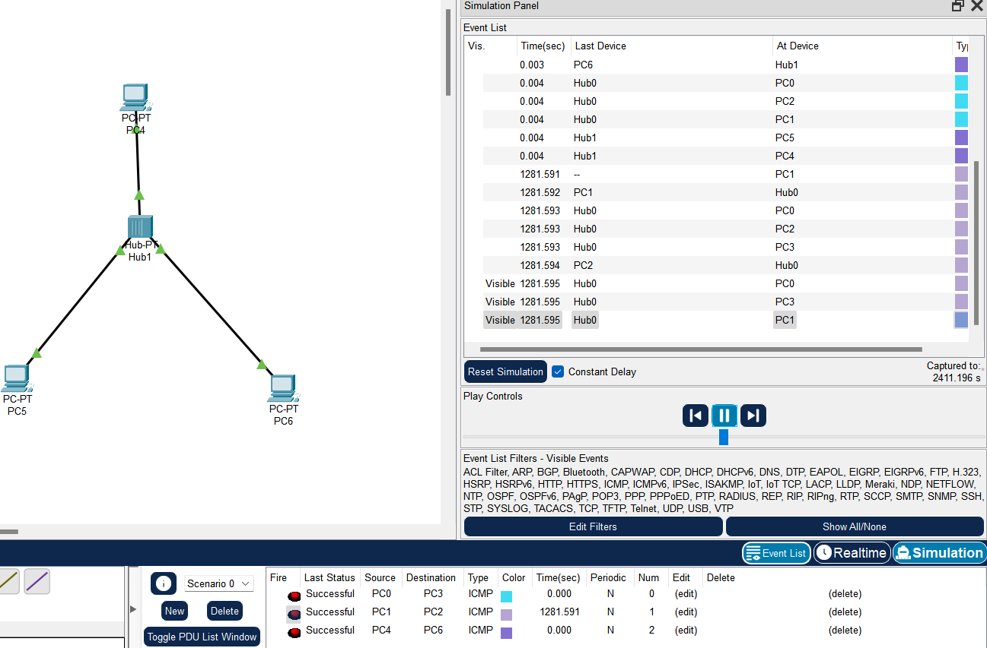



TASK-2:-

Submit a lab with performing a simple task by designing a topology with four PC’s connected to

switch. Show that when mac-address table of switch is empty it broadcasts the traffic and also

show number of collision and broadcast domain of this topology using simulation mode of

packet tracer with screen shots

